# 1. Extract Data

For extracting data, I used SQL with 2 different queries.

1. Extract city_data table

SELECT * FROM city_data

1. Extract global_data table

SELECT * FROM global_data

The result are exported into csv file

# 2. Open CSV File

To open the CSV file, it’s possible to use excel for examining data and analyze it. If I straightly open the CSV file, then it is harder to read the dataset. I had to import it using excel’s “To CSV”.

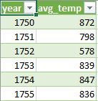

It looks odd because when I extracted the data, every row should be in decimal number. To fix this problem, I divided every row by 100.

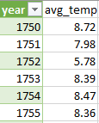

The global_data successfully imported, but the city_data is yet to be imported.



There are two problems here. First, the avg_temp is not in the correct format which I had to divide them by 100. Second, there are null values on a few rows. For the null values, I fill down the value from the previous year.



# 3. Create a line chart

To make line chart, I use Tableau instead of excel because if its ease of use.

Currently, I live at Bandung, Indonesia. So I can just filter only Bandung city to compare it with global temperature. Here is the comparison between Bandung city and global temperature.

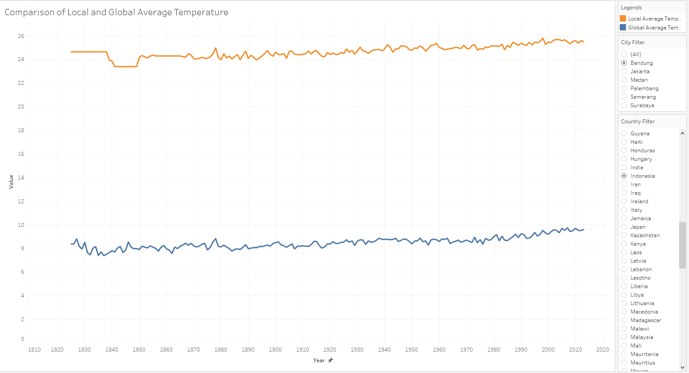

The yellow line is the average of Bandung city temperature, while the blue line is the average of global temperature.

To make the visualization smoother, Moving Average is needed. Fortunately, tableau gives me the function to visualize the Moving Average. I used 3 Year Moving Average.

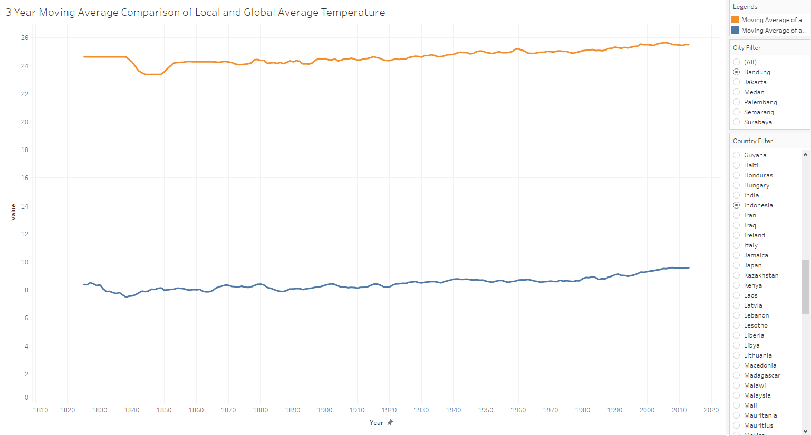

Finally, I created linear trend line to find its R-Squared on each line

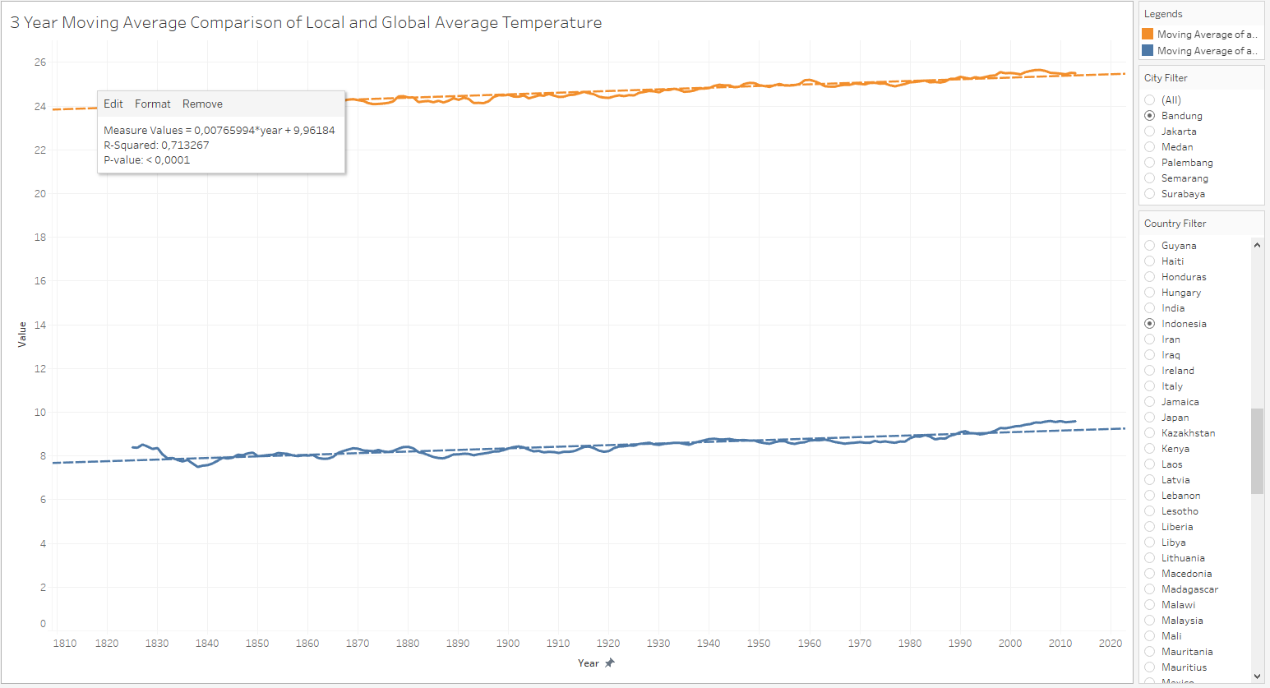

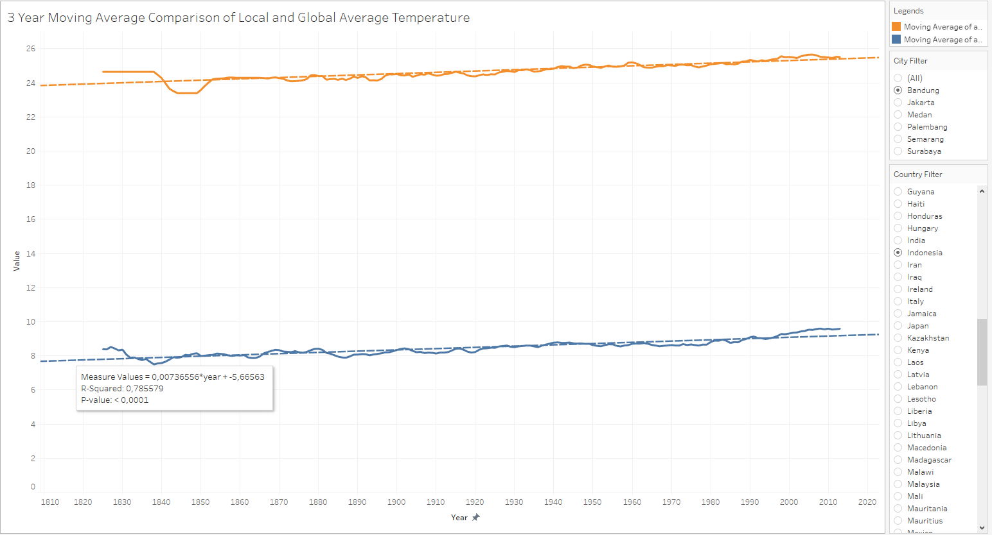

Here is the R-Squared of each line :

3 Year MA Local temperature : 0.713267

3 Year MA Global temperature : 0.785579

# 4. Make Observations

* From the above line chart, Bandung city is definitely hotter than the global average temperature.
* To see the difference over time, I have to visualize it as below

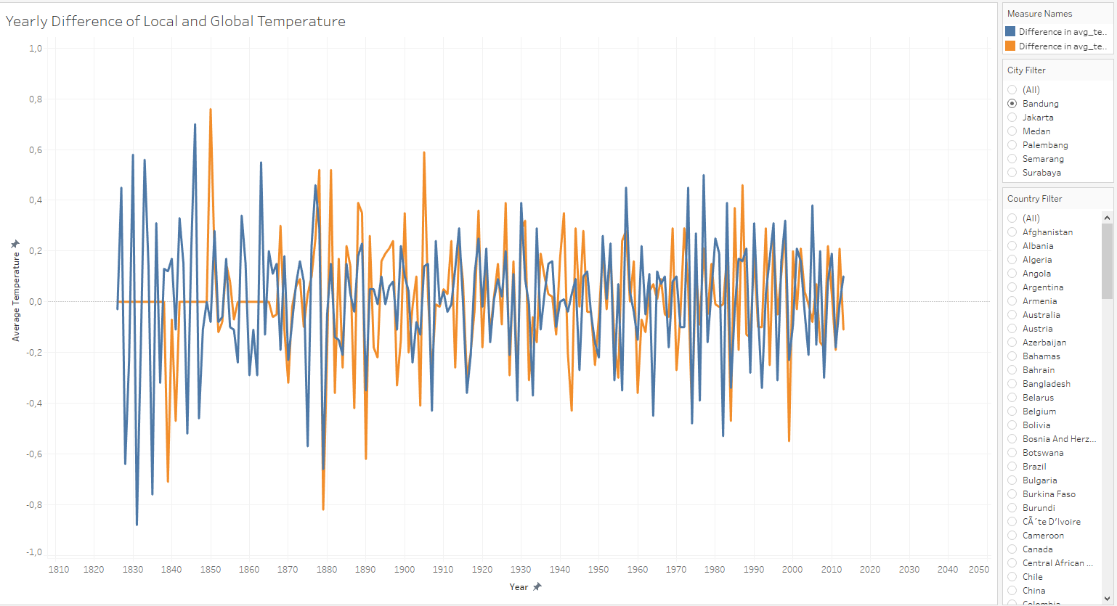

And it looks like the difference is not consistent. Some year it was hotter, and some year it was colder. But the visualization tells us that the temperature difference never go above or below 1 degree. I think it is a good thing to know that the temperature change is not much different from how it was in 1800’s.

* According to the calculated R-Squared value, there is a positive linear correlation between the average temperature and the year. So, we have to concern that the trend is positive, meaning that the world is getting hotter.
* By comparing the local and global R-Squared value, it looks like the global R-Squared value is higher than the local R-Squared value. That means Bandung City temperature is a little more consistent rather than global temperature.

For more detailed visualization, I created dashboard combining 3 Year MA and yearly difference visualization

